ProjectLibre

How to get ProjectLibre:
ProjectLibre is available for download from: http://www.projectlibre.com/

Changing the language to English:
If the language is not in English, the language can be changed as follows:
- Create a directory “C:\Users\[Your user name]\.projectlibre”

To do this, right click on the Windows icon on the task bar
Select “run”
Cmd

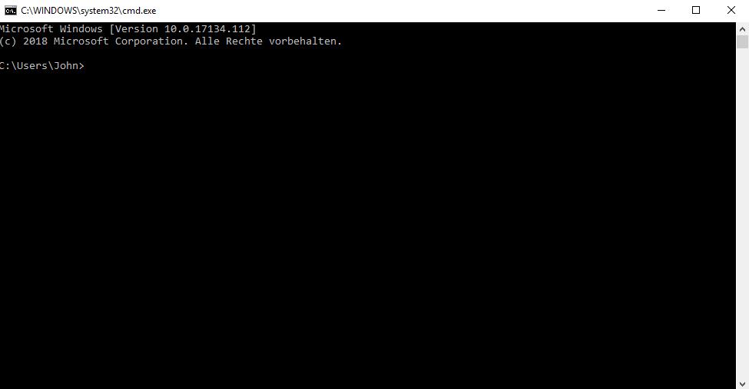

- Enter the command: mkdir .projectlibre

To check it was successful, typ the command: dir

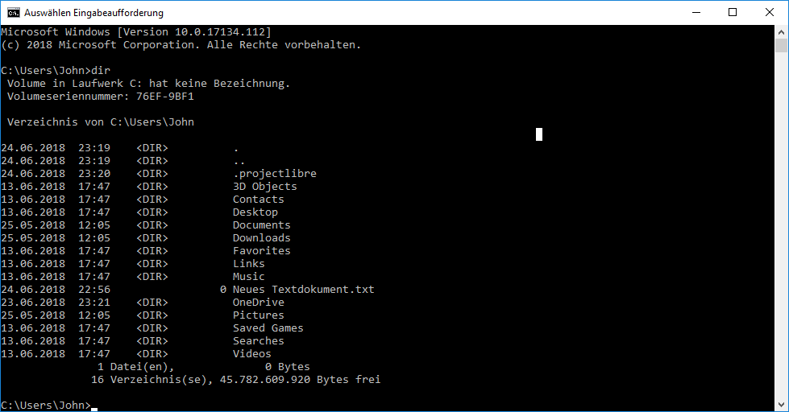

- Use the editor to create a file called “projectlibre.conf”

In this file, enter the single line: “locale=en” and save it.

- To exit the cmd window, type the command “exit”

For further information, please refer to the link: http://www.projectlibre.org/discussion/changing-language-interface-date-format-and-currency-projectlibre

Adding a progress column
From the “Gantt Chart” view, click on the column marked “I”
Select “insert column”
Select the filed “percent complete”

General Introduction to Project Libre
Start with the header bar:
File: Allows you to save and print your project
Task: Allows you to add, delete, and change tasks. It can also show the project in different views: Gantt Chart, Network Diagram, etc.
Resources: Allows you to add and delete resources (people) for the project. It also provides a resource usage view for checking for resource over-allocation
View: Allows you to select various views of the project

On the right-hand side of the header bar, you can select various different sub windows which then appear at the bottom of the screen. To remove them, click on the white box.

The two views you will use the most are:
Task/ Gantt
Resource/ Resource Usage

Task dependencies:
The default dependency in Project Libre is: Finish-Start. (When task A finishes, task B can start)
Project Libre also supports the dependencies:
Finish-Finish (task B finishes at the same time as task A)
Start-Start (Task B starts when task A starts)
Start-Finish (Task B finishes when task A starts)

To create a dependency, you can either
- Edit the field “Predecessors”
- Mark two or more tasks with the mouse, and then click the “link” button in the task menu

To add a milestone, set the duration to 0 days.

Resources
To assign resources (people) to a task, first create the resources in the resource menu.
Then, from the task menu, you can directly assign resources to a task by selecting them in the resources column or clicking on the “assign resources” button.

